User Guide 1A Lodging party created applications
Purpose of this User Guide
The purpose of this guide is to provide information on how a lodging party can create applications in SPEAR.
Who should read this guide?
Primary audience: Lodging parties
For information: Land Use Victoria
Introduction
The SPEAR Electronic Lodgment Network allows lodging party subscribers to electronically create and lodge non-survey-based applications in SPEAR.

Once the application has been created in SPEAR, you can create the application lodgment form and upload all mandatory and supporting documents.

  - Transfer of Land Act (TLA) applications that can be created and lodged in SPEAR
A lodging party who is a registered SPEAR subscriber can create and lodge the following non-survey Transfer of Land Act (1958) dealings:
- Section 60(1) Application for a vesting order based on title by possession*
- Section 15 Application to bring land under operation of the Transfer of Land Act (1958)
- Section 45 Creation of Easement**
- Section 72 Recording of Easement
- Section 88(2) Acquisition of Easement or Right
- Waive Survey
- Section 28 – Crown grant ***
- Section 28 – Crown lease ***
* Can only be signed and authenticated by an Australian Legal Practitioner.
** Currently the lodging party must be representing both servient and dominant parties.
*** Section 28 Crown Dealings are available for lodgment by DTF and DELWP.
  - Other applications that can be created and lodged in SPEAR
The following non-survey applications can be created:
- Section 259 Major Transport Projects Facilitation Act (1988)

The following Subdivision Act (1988) applications can be created:
- Section 33(1) Alteration of lot entitlement and liability
- Section 38 Accessory Lot - Removal
- Section 38A Notice of Restriction - Removal
- Section 38B Amend Scheme of Development – Owners Corporation
- Section 38C Amend Scheme of Development – Lot Owner
  - How do I create a new subdivision application in SPEAR?
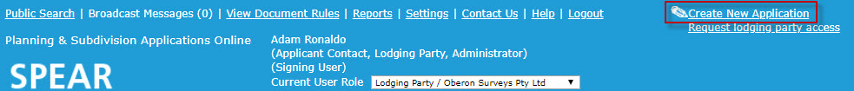
Login to SPEAR using your username and password. This will open the Applications List. Select Create New Application from the top right of the screen.

Step 1 – Create Application Details
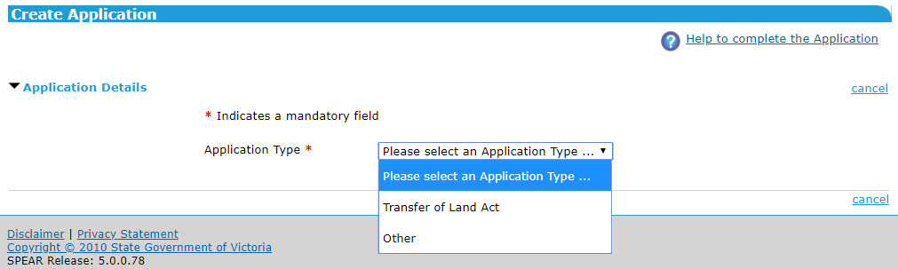
Choose an Application Type from the drop-down list.

Step 2 – The Land
Click ‘text search’ to define the land in the application. The Parcel Search pop-up window will appear.
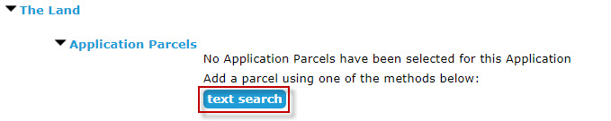
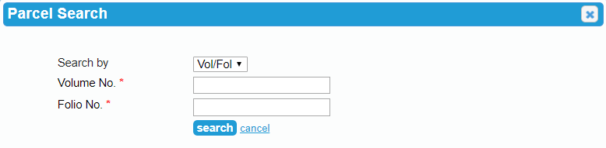
Enter the required property details and click ‘search’. SPEAR will perform a database search to confirm the address and other relevant parcel information.

Once your application parcel(s) search is returned from the database, select the checkbox and click ‘Add to Application’.
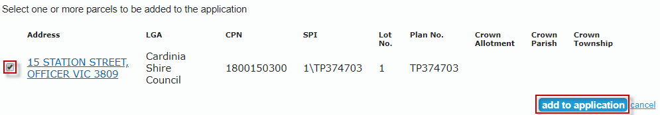

You can perform additional searches and add multiple parcels to your application if required by using the ‘text search’ button and repeating the previous steps.
If you have added multiple parcels to an application, you will need to select which parcel is the primary parcel.
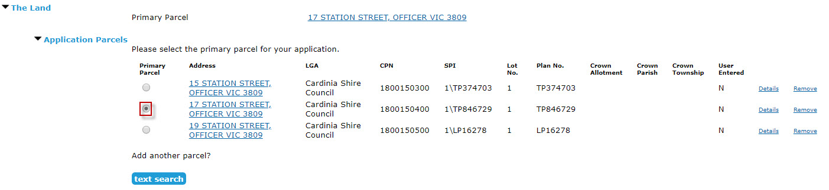
NOTE: If you must search by another method other than Volume and Folio, you can add these manually using the ‘Other’ search by selection in the drop-down list and click ‘add manually.’
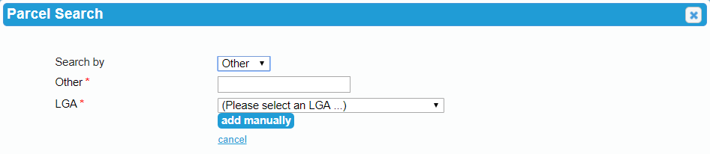

Step 3 – The Proposal
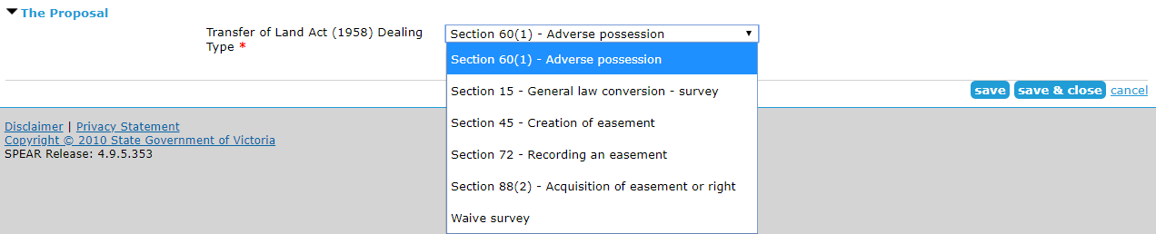
Select the dealing type from the drop-down list.
NOTE: Mandatory fields are indicated with a red asterisk (*).
Click ‘save & close’ when you are ready to continue.
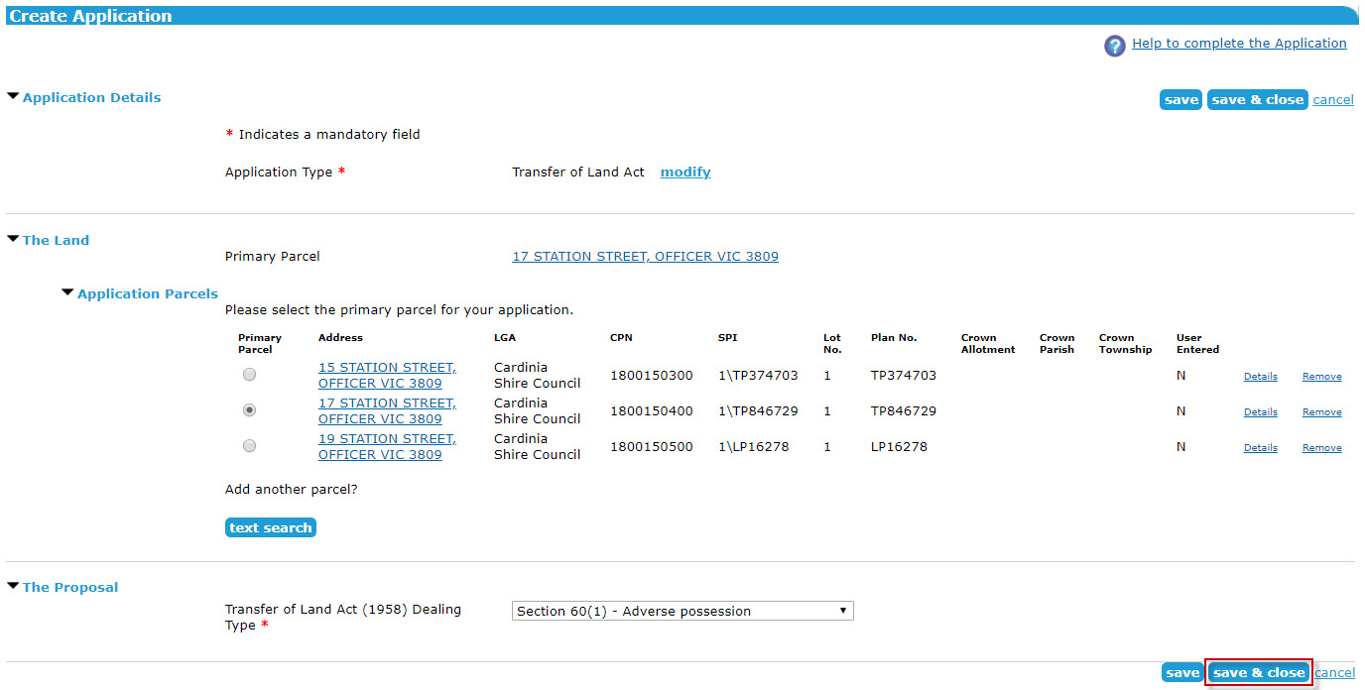
NOTE: Click ‘save’ at any time to allow SPEAR to validate the fields and highlight any errors, or ‘save and close’ to return to the Details screen. From the Details screen you can return to this document and make any changes by selecting ‘Modify’, shown alongside the Dealing type details document.

Step 4 – Mandatory Actions
You will now be prompted to carry out several mandatory actions before the application can be submitted to Land Use Victoria for pre-lodgment check.
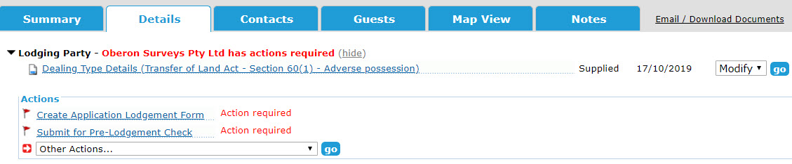
NOTE: The example portrayed in this User Guide is for a Section 60(1) Adverse possession under the Transfer of Land Act (1958). The displayed fields may differ depending on your application type.

Mandatory actions may include Copy of Title(s), Government Gazettes etc. The documents that SPEAR prompts you to add as mandatory actions will be dependent upon the type of application you are preparing to submit.
Optional actions are available by using the ‘Other Actions…’ drop-down list. Optional actions allow you to add additional supporting documentation, such as a covering letter, reports, or photos. If you cannot find an optional action to suit your needs, select ’Add Other Supporting Document’ or ‘Add Other Document Type’ for anything that falls outside the selections available.
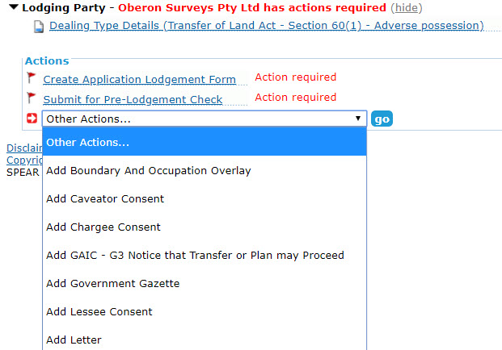

NOTE: Transfer of Land Act dealings often require evidence to be supplied before submitting for pre lodgment-check.
You can find further information about attaching documents in User Guide 43 - Key SPEAR Screens.

Step 5 – Create Application Lodgement Form
Application Lodgement Forms can be created using the mandatory action the moment the application form has been completed and the application is live.
The correct Land Use Victoria forms are generated automatically with information prepopulated by the system, based on information provided throughout the application.
You can find further information about creating an application Lodgement Form in User Guide 11 – Lodging an application at Land Use Victoria

Step 6 – Authenticating Documents
Once all required documents have been supplied, they must be authenticated.
Application lodgment forms as well as some other documents require a digital certificate for authentication which is typically held by a solicitor or licensed conveyancer.
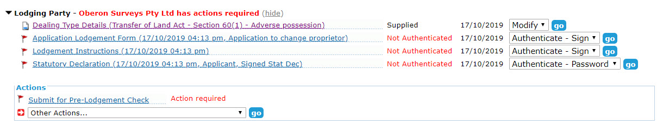
If you do not have the required access level, you can use the ‘Notify for Authentication’ feature to notify someone in your organisation to authenticate documents.
You can find further information about authenticating documents in User Guide 42 - Authentication – User Levels & Documents

Step 7 – Submit for Pre-Lodgment Check
You can provide details of any leader or follower dealings that will be lodged with the plan.
Once you have clicked ‘submit application’, Land Use Victoria will check to ensure it is fit to be lodged. You will be notified by SPEAR when the application is ready to pay and lodge. An exact fee will be included in the notification email.

Step 8 – Can I modify my application in SPEAR?
Most details can be modified in an application while it is in draft status. If changes are required after the application has been submitted for pre lodgment check, you will have to select ‘Cancel Submission to Land Use Victoria’ from the ‘Other Actions’ drop-down list.

  - Who can see my draft application?
Only users within your organisation can view a draft application before it has been submitted for pre-lodgment check.
Once the action ‘Submit for Pre-Lodgement Check’ has been performed, the application status will change to ‘Pending Lodgement’ and Land Use Victoria can view your application.
  - How to withdraw your SPEAR application
If an application status is at ‘Draft’ in SPEAR, the lodging party can delete the application from by selecting the ‘Delete application’ action from the ‘Other Actions…’ drop-down list.
If you no longer wish to proceed with an application that has been submitted to Land Use Victoria pre lodgment check, and a decision has not yet been reached, it can be withdrawn. The ‘Cancel Submission to Land Use Victoria’ action is available via the ‘Other Actions…’ drop-down list. Once at a status of ‘Pending Re-Submit', you will be able to select ‘Withdraw Application from SPEAR Permanently’ via the ‘Other Actions…’ drop-down list.
If you have completed the ‘Pay & Lodge’ action, this application can only be withdrawn outside of SPEAR. Please contact Land Use Victoria on how to complete this process.

Need more information?
Further information on this topic can be found by:
- Visiting the SPEAR website www.spear.land.vic.gov.au/SPEAR
- Contacting the SPEAR Service Desk on 9194 0612 or email spear.info@delwp.vic.gov.au
- Selecting the Help link in the relevant area of the SPEAR system.
- Referring to:
- Tech Note 4 – Applicant Contact Created Documents in SPEAR
- User Guide 11 – Lodging an Application at Land Use Victoria
- User Guide 42 – Authentication – User Levels & Documents
- User Guide 43 – Key SPEAR Screens

